MLD

ENG 102

READ SMART

STUDY STRATEGIES

2018-2019 Academic Year
Reading dense, lengthy academic texts can be a boring and difficult experience. However, as a university student, you need to learn to deal with such texts as you will be expected to read several scholarly sources. The trick is to read smart.

To read smart;
- Read with a purpose
- Read strategically
- Read actively (annotate)
- Read critically
- Consider writer’s technique

1. READ WITH A PURPOSE

X Do not just read for the sake of reading and do not treat an academic text like a novel. Try
to develop an academic approach to reading

X Do not just dive straight into the text, think and identify what you want to get out of the
text.
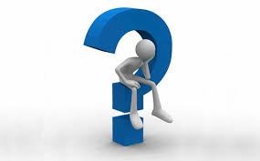
Strategy:
Always ask yourself the following questions:

- Why am I reading this?

Are you reading to find an answer to a question?
What subject will this article prepare you to discuss?
How does this article fit into the main questions or topics of the course?
What will the instructor ask me to do with the knowledge I gain from the article?
Are you looking for data, examples, opinions?
Do you need to verify something you read elsewhere?
- What might I need this information for?

Will you use it as a source to support your argument?
Will you write a reaction to it?
Will you answer an exam question?

2. READ STRATEGICALLY

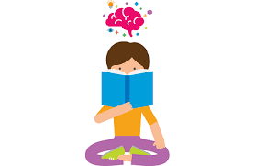
X Do not feel overwhelmed by the density and length of the texts. Read smart!

Strategy:
- Read the abstract first! Check if it is relevant to your purpose/assignment
- Read the introduction and conclusion or the discussion part to identify the position of the author: the claim, thesis, or argument
- Go through the subtitles to have an overall understanding of the text
- Utilize the references for further research. This could be a gateway into several other useful texts about the same/similar topic.

3. READ ACTIVELY
Academic reading is not a passive activity. It requires active reading, which is the ability to approach the text as something that needs a response from you. That is, active reading requires full engagement with the text.
Reading is not about answering a set of comprehension questions. It is a process of thinking and an inner conversation with the text.

Strategies:

- always read with a pencil in hand as you read
- preview: consider the text structure
- get a sense of what the text is about and how it is organized
- skim to get an overview of the content and organization. Pay attention to:
- identify the main argument(s) or idea(s) in the text
- predict, visualize, connect ideas
- infer; draw conclusions
- react to the arguments, ideas, claims
- annotate (see the next page for the details of annotation)

TEXT ANNOTATION

Annotating is underlining or highlighting key words/phrases/parts as well as making notes and comments in the margins of a text as you read. In other words, it is having a conversation with the text; it involves more than just highlighting some parts of it. In fact, it is an excellent way to help you formulate your own ideas for writing assignments based on your reading.
Leave tracks of thinking as you read

Benefits of Text Annotation

- helps you identify key points
- helps you locate and interpret the meaning
- helps you remember more
- encourages you to notice and think about the features of the text
- keeps you from getting distracted and missing important points.
- helps you read actively and develop your critical analysis skills

How to annotate

As you are annotating a text, you may make margin notes to;

- label the important information, main ideas, key concepts, definitions, examples, characteristics, key features, causes, effects, reasons, similarities, differences, names, dates, events
- define the key words, collocations, phrases or expressions
- highlight puzzling or confusing ideas that need clarification
- trace the development of ideas or arguments throughout the text
- express your thoughts, reactions, criticism, agreement or disagreement to the ideas or arguments in the text,
- formulate or pose your own questions about the topic, ideas or arguments in the text
- make connections to your personal experiences or ideas from other texts or class discussions.

When annotating, you can use symbols to capture your reactions. Below are some symbols that you can use in the margins of a text.

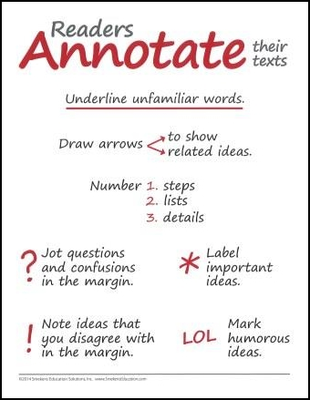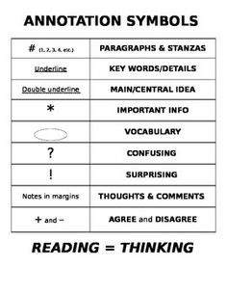

Below is an example text annotation:

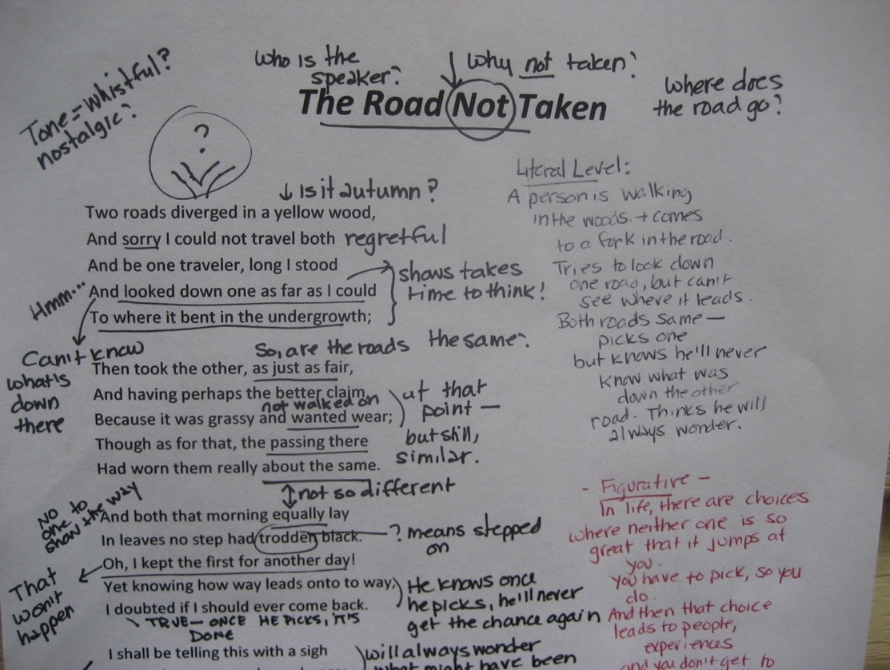

For further study, you can visit the links below:
https://www.youtube.com/watch?v=pf9CTJj9dCM
https://www.youtube.com/watch?v=NmVAfoXhhPM
https://www.youtube.com/watch?v=pf9CTJj9dCM
4. READ CRITICALLY
Critical reading is the process of reading that goes beyond just understanding a text.

Writers generally make assertions that they want you to accept as true. As a critical reader, you should not accept anything on face value but to recognize every assertion as an argument that must be carefully evaluated. You should question the statements made by the author so that you can identify the strengths and weaknesses of the argument put forward. When you assess an argument, you are concerned with the process of reasoning as well as its truthfulness. (See p. 2 of Module 1- Academic Writing Input for information on arguments)

When reading critically, consider the following question:
- Who is the author?
- What type of source is it?
- What evidence is used to support ideas?
- Is the evidence fact, research, opinion, or personal experience?
- Is the evidence accurate? Is it convincing?
- Is the evidence relevant to the conclusion?
- What are the counter arguments?
- Are there any contradicting parts?
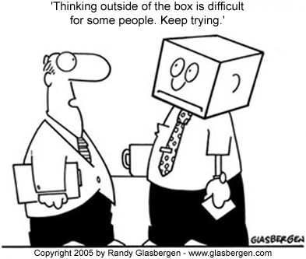
- Are there any flaws in the reasoning?
- Are conclusions based on facts or opinions?
- Are there any logical fallacies?
- Are there any author biases?
- Are the writer(s)’s arguments strong?
- Are there logical connections between the claim and the evidence?
- What other perspectives are there on this issue?
- How does it relate to other sources and research?

For further study, you can visit the links below:
https://www.youtube.com/watch?v=iOGvwPmKOqQ
https://www.youtube.com/watch?v=L6jFea6OT94
https://www.youtube.com/watch?v=5Hc3hmwnymw
https://www.youtube.com/watch?v=H2znt-udk1A

5. IDENTIFY WRITER’S TECHNIQUE

Critical readers also consider writer’s technique, bearing in mind that different authors present the same information in different ways, which is due to their own unique style. Two texts on the same topic might present totally different perspectives and the writers might totally hold a different stance (position, argument or thesis- where they stand). For this reason, each text might have a different method of organization, purpose and tone. Therefore, an effective academic approach to reading requires recognizing the writer’s technique.

To be able to identify writer’s technique, you should identify:

- Audience - the group whom the writer intends to address
- Purpose - the reason the writer writes
- Tone - the attitude the writer conveys

To identify the purpose and tone of a text, you need to use text-based evidence (textual clues such as word choice).

Purpose | Tone
Every writer has a purpose for writing, which is actually his reason for writing.  Below are some common purposes: | Tone is the writer’s own attitude toward the subject. It indicates the writer’s voice and attitude towards the issue and is not expressed or explained directly in the text.  A writer’s word choice, point of view, stance and level of formality determines his/her tone, which is described by adjectives such as:
To…  inform amuse warn  persuade compare suggest  explain contrast illustrate  prove describe list  criticize | informative ironic accusing  critical objective approving  impartial subjective offensive  cynical neutral skeptical  angry optimistic provocative  annoyed pessimistic humorous  indifferent serious cautious

Study how the word choice helps you to identify the tone and purpose of the writer in the following excerpt:
Celebrity photographers, also known as paparazzi, have gone too far in their quest to snap pictures of the stars. Everyone—even celebrities—should have the right to privacy, yet photographers routinely hound famous people everywhere they go. The creepiest of these photographers are not above following their prey into bathrooms or climbing trees to get shots of celebrities in their own homes. This constant invasion forces the rich and famous to become rude and mean, setting a bad example for their often youthful fans. Even worse, though, the paparazzi's behavior is frequently downright dangerous and irresponsible.

(Source of information: Michael Paul, Lenoir, NC, "Paparazzi Go Much Too Far," USA Today, September 9, 2004, p. 12A)
The author's purpose is to _____________________________
The author's tone is ___________________________________
For further study, you can visit the links below:
https://www.youtube.com/watch?v=ehYMAVDkyLM
https://www.youtube.com/watch?v=pYFbRam2jUE
http://fsc.lonestar.edu/GCPASS_lonestar/PREPReading/prepreading_topic7.htm
https://www.youtube.com/watch?v=5zaLT1Q2VPE

Study the paragraph below to see the traces of read smart strategies.
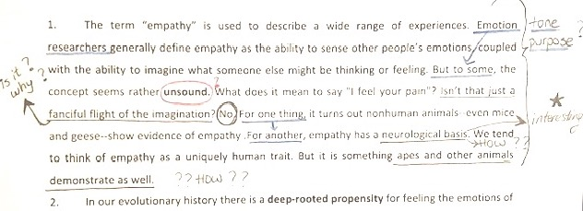

OVER TO YOU

EMPATHY TEXT 1: “EVOLUTION OF EMPATHY”

Task 1: Read paragraphs 6, 7, 8 actively and critically.
- annotate them to leave your traces of thinking
- write critical thinking questions where possible
- identify tone and purpose

T’s NOTES
You can either get your students to compare their work with the ones given below or prepare your own analysis or annotation of the text. Alternatively, together with your students, you can do ‘think aloud’.
Paragraphs 6,7 and 8 of the first reading text:
