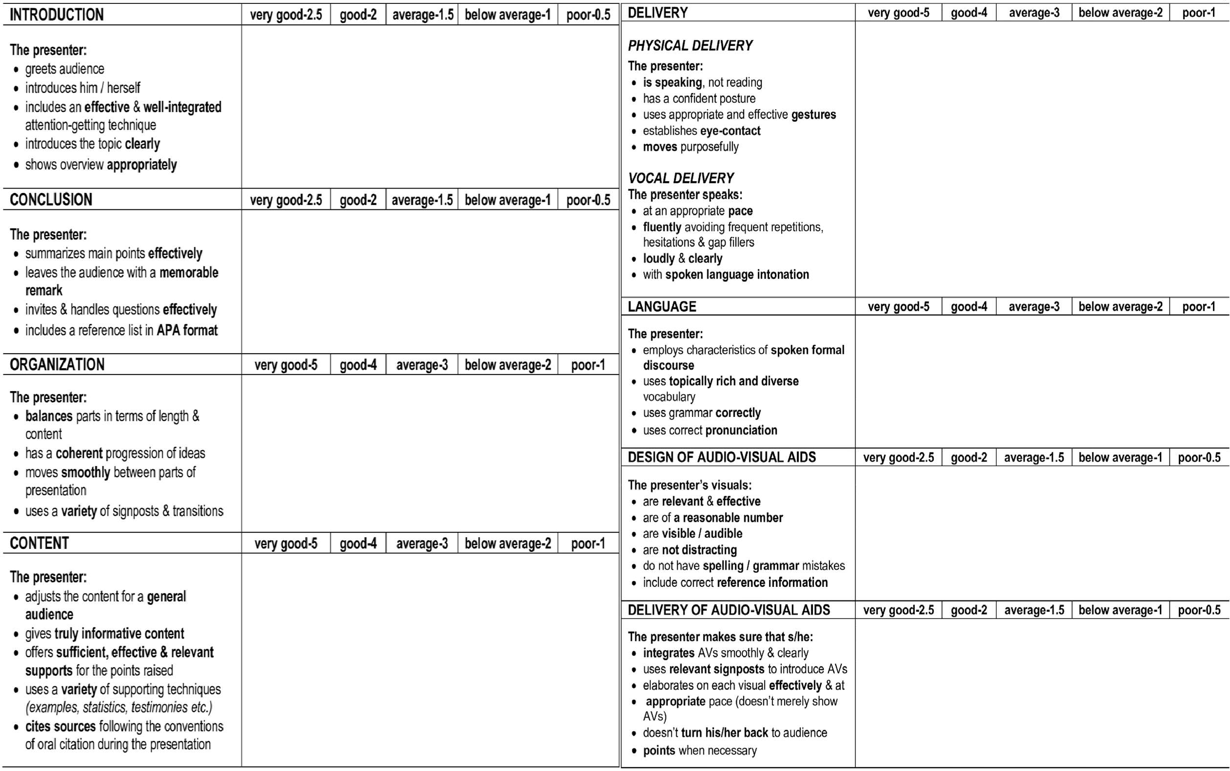
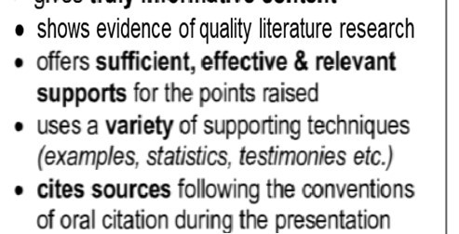
Name: ___________________________
ENG 211- FINAL PRESENTATION RATING SCALE
Rater: ____ Session no:
(Duration: 7 minutes) Time:
Section:________Grade:__________

*Deduct points from the related sections in case of extreme reading & memorization.
*If the student presents a different topic than the 4 themes in the course book (mind, art, marketing, science & technology), deduct 10 points from the final grade.

Time Management: Deduct points from Final grade if student exceeds time limit: over 7’30’’: -1; over 8’: -2; over 8’30’’: stop the presentation & deduct 2 points.

